Dr. Ahana Purushothaman

Assistant professor

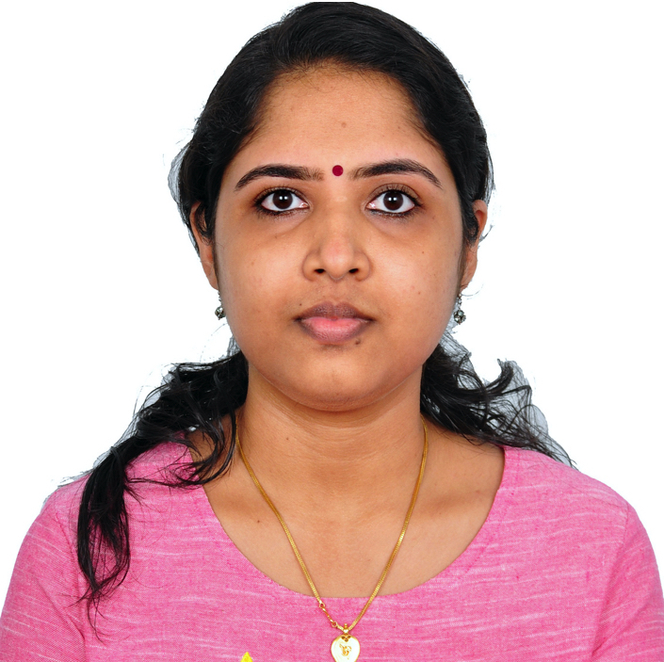

Personal Data:

Nationality | Indian

Date of Hire | 20/08/2023

Date Rank Obtained | 20/08/2023

Department | Chemical Engineering

Email | anithin@kfu.edu.sa

Office No |

Office Phone No |

Education:

|  |  |  |  |  |  |
| --- | --- | --- | --- | --- | --- |
| **Academic Degree** | **Major** | **specialty** | **Place of Issue** | **Address** | **Date** |
| Doctorate (PhD) | Chemical Engineering | Chemical Engineering | Indian Institute of Technology (IIT) - Madras, India | Indian Institute of Technology (IIT) - Madras, Chennai, Tamilnadu India | 06/07/2021 |
| Masters (M.Sc.) | Chemical Engineering | Chemical Engineering | Indian Institute of Technology (IIT) - Bombay, India | Indian Institute of Technology (IIT) - Bombay, Mumbai, Maharashtra, India | 30/05/2015 |
| Bachelor (B.Sc.) | Chemical Engineering | Chemical Engineering | National Institute of Technology (NIT) - Calicut, India | National Institute of Technology (NIT) - Calicut, Kerala, India | 30/05/2012 |

PhD, Master or Fellowship Research Title: (Academic Honors or Distinctions):

|  |  |
| --- | --- |
| PhD | Hydrodynamics of channel confined micro-swimmers |
| Master | Computer Aided Molecular Design (CAMD) of Ionic Liquids (ILs) |

Experiences:

|  |  |  |  |  |
| --- | --- | --- | --- | --- |
| **Title of Job** | **Address of Work** | **Country** | **Date** | |
| Post doctoral researcher | ICSR, IIT Madras, Tamilnadu, India | India | From | 15/04/2021 |
| To | 23/05/2023 |

Research Interests:

1. Hydrodynamics of active particles
2. Heat transfer in Polymer crystallisation
3. Lattice Boltzmann simulations

Publications:

|  |  |  |  |  |
| --- | --- | --- | --- | --- |
| **#** | **Name of author(s)** | **Title of Publication** | **Publisher and Date of Publication** | **Link of Publication** |
| 1 | Ahana Purushothaman,S Adhikari, C Durning, S K Kumar and Sumesh P. Thampi. | Directional Polymer Crystallisation with a fast-moving sink. | Soft Matter 19, (2023): 4011-4020. | <https://pubs.rsc.org/en/content/articlelanding/2023/sm/d2sm01589g/unauth> |
| 2 | C Durning, Ahana Purushothaman, S Adhikari, S K Kumar and Sumesh P. Thampi. | Physics of Directional Polymer Crystallisation | ACS Macroletters 11, (2022): 1102-1106. | <https://pubs.acs.org/doi/abs/10.1021/acsmacrolett.2c00346> |
| 3 | S Adhikari,Ahana Purushothaman, A A Krauskopf, C Durning, S K Kumar and Sumesh P. Thampi. | Modeling polymer crystallisation induced by a moving heat sink. | Soft Matter 17, no. 9 (2021):2518-2529. | <https://pubs.rsc.org/en/content/articlelanding/2021/sm/d0sm02237c/unauth> |
| 4 | Ahana Purushothaman and Sumesh P. Thampi. | Hydrodynamic collision between a microswimmer  and a passive particle in a micro-channel. | Soft Matter 17, no. 12 (2021): 3380-3396. | <https://pubs.rsc.org/en/content/articlelanding/2021/sm/d0sm02140g/unauth> |
| 5 | Ahana Purushothaman and Sumesh P. Thampi. | Colloidal hydrodynamics using a quasi-steady algorithm in lattice Boltzmann method. | Bulletin of Materials Science 43, (2020): 1-9. | <https://link.springer.com/article/10.1007/s12034-020-2074-z> |
| 6 | Ahana Purushothaman and Sumesh P. Thampi. | Confinement induced trajectory of a squirmer in a two-dimensional channel. | Fluid Dynamics Research 51, (2019): 065504. | <https://iopscience.iop.org/article/10.1088/1873-7005/ab4d08/meta> |

Language Proficiency:

1. English
2. Hindi
3. Malayalam